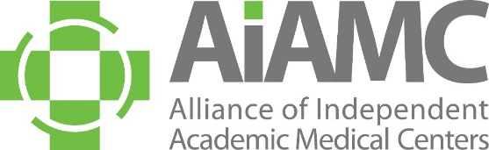

OFFLINE REGISTRATION FORM
National Initiative IX
Meeting One

Name:
Title:
Organization: ____________
E-Mail: ____________

Registration Fees: National Initiative IX Meeting One

□ $50 Team Leader (one per team)
□ $240 Additional Team Members

Payment: □ American Express □ Visa □ MasterCard

Account #:
Amount: Exp. Date: CCID Code:
Billing Zip Code:

Send completed form to AIAMC Administrative Coordinator Mindi Apicella via email mindi@aiamc.org.
If you prefer to call-in your credit card information, Mindi’s direct line is 407.709.5520.
A receipt will be emailed to the address you provided above.

